High Speed Networking for Storage

* 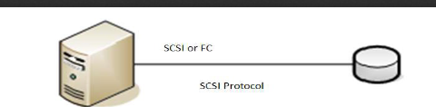Direct Attached Storage (DAS)
  + Architecture for storage is privately attached to servers
  + Can’t be shared, hard to scale, expensive and complex to manage
    - 80% of market is this
    - For an individual user, the hard drive the form of DAS
    - In Enterprise however, finding a way where storage can be shared by multiple computers and users tend to be more efficient and easier to manage
    - SCSI used to talk to dedicated and embedded devices on the network
* 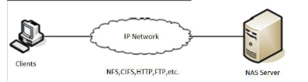Network Attached Storage (NAS)
  + File-level computer data storage connected to IP network providing data access to heterogeneous group of clients
  + Removes responsibility of file serving from other servers on network
  + Provides access to files using network file sharing protocols like NFS, SMB/CIFS, AFP
  + Have dedicated storage server, and dif clients can access this storage through IP network.
  + Have dif protocols used to run traffic on top of that ip network for clients to talk to eachother.
* 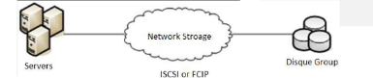Storage Area Network (SAN)
  + An independent network for storage subsystems, free from rest of computer network
  + Dedicated network providing access to consolidated, block level data storage ‘
    - A Fiber Channel Network
      * Uses network of fiber channel connectivity: FC switches and Directors
      * An FC SAN uses FCP for transport
        + FCP- serial small computer system interface
      * FC (FIBRE CHANNEL)
        + A high-speed network technology used for storage networking
        + Signaling can run on twisted pair copper wire in additional to fiber-optic cables
        + Standard connection ntype for SAN in enterprise
        + FCP- Fiber Channel Protocol

Transport protocol similar to TCP that transports small cpu system interface commands over FC networks

* + - A network that is INDEPENDENT of storage subsystem.
    - See that when covering topic of distributed file systems/dif ways to store ton of data on network storage devices.
    - Typically store on multiple separate storage devices, NEED A WAY for these separate devices to talk to each other through a Fiber Channel (the yellow cables in rack pic) very faaaaast, much faster than regular ethernet cable.
    - In SAN the whole design based on fact that have dedicated network that maintains communication with the SAN.
    - Fibre CHANNEL IS KEY HERE
    - An IP Network
      * Uses standard LAN infrastructure (Ethernet switches)
      * For Transport an IP SAN uses iSCSI
        + iSCSI- serial SCSI-3 over IP

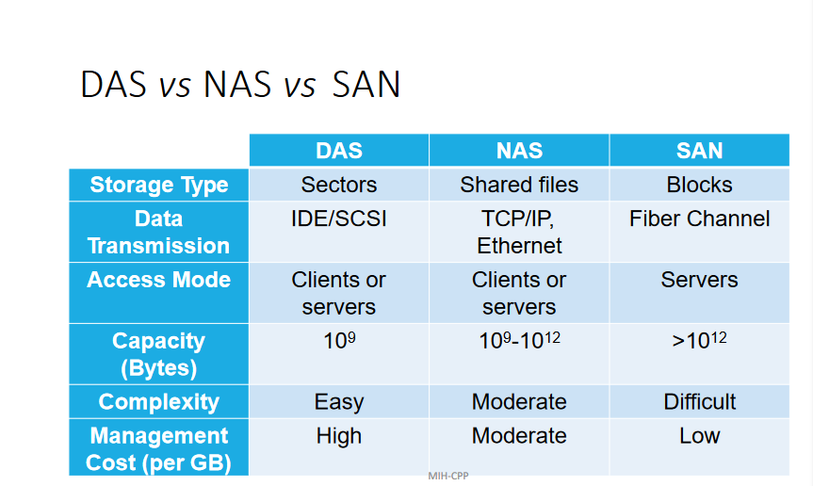

When using a RACK, need FAAAST network for all nodes to communicate with eachother